**EVALUATING GROUNDWATER QUALITY PARAMETERS AND PATRONAGE AT (ABURA, ASEBU, AND KWAMANKESE DISTRICTS IN THE CENTRAL REGION OF GHANA)**

**Alex Osei Anyimadu and Jonathan A. Quaye-Ballard**

*Department of Geomatic Engineering, College of Engineering,  
Kwame Nkrumah University of Science & Technology, Kumasi, Ghana.  
Email: oseialex2022@gmail.com*

# ABSTRACT

***Evaluation and mapping of groundwater quality are important for alleviating environmental challenges towards accessing groundwater. The study focuses on measuring the status, mapping groundwater quality parameters, analysed accessibility map, and administering a questionnaire of Aboase, Obohen, and Bentinqua communities’ groundwater, from the traditional water quality data, using traditional laboratory work method, Geographic Information System (GIS), Global Position System (GPS), Statistics analysis for the questionnaire. Analysis of eleven groundwater samples was conducted for pH turbidity, total dissolve sold, total suspended solids, and total iron. The results of the parameters were compared to the WHO standard reference base accepted rate, and the results from the accessibility map and the research questionnaire were compared to the Word Bank Reference measure of 200m. In all three spatial maps, give a correct result: traditional laboratory method, Accessibility map, Spatial distribution map of groundwater, and research questionnaire. Overall, the results from the laboratory report indicate that the equipment and the software applications used were able to elicit the necessary results on the above-stated communities’ groundwater quality parameters. The measured results acquired, on the status of groundwater quality, Accessibility map, and Research questionnaire analysis were pH (7.01mg/L), Turbidity, (2.6mg/L), Alkalinity (0.2mg/L), Chloride (52mg/L), TSS (mg/L), and microbial contamination (>0.8mpn) TDS (1.45mg/L), accessibility map to be 450m, 350m, 375mm and finally, Research questionnaire with high percent agreed water from improve water been better to that of unimproved in terms of quality and with distance be a barrier in accessing groundwater from source to the household. All the measures of water quality parameters are within the acceptable criteria, except for total iron (0.3mg/l) and microbial contamination (>0.8mpn) which exceeded the expected threshold and it needs possible chlorination to correct that error. The difference in distance from the various households to the source needs to be fixed by authorities; with one of the high-yield boreholes to be mechanized and supplied to their respective homes.***

***Top of Form*Keywords:** Groundwater Quality, Geographic Information System (GIS), Accessibility Map, Water Quality Parameters

# INTRODUCTION

Changes According to Cromwell et al. (2020), the method for accessing rural water has been demanding issues concerning rural folks worldwide for several decades and was incorporated into sustainable development goals (SDG 6). Additionally, rural communities in Ghana have abundant natural water resources like rivers, streams, Ponds, and lakes; utilizing them can lead to negative outcomes due to contamination from human activities that have resulted in the country not attaining sustainable development goals on water quality (WHO, 2004). According to Mukherjee et al., (2012), groundwater is a crucial location of fresh water for households, agricultural, and industrial uses worldwide and it is becoming increasingly important in developing countries due to its advantages over surface water. Furthermore, Anim-Gyampo et al. (2012), that ground is the available source of water that provides water to 70% of the Ghanaian population, and the availability depends on geological formations, the nature of pores, and rainfall. The continuous economic growth and population increase have led to groundwater quality problems due to pollution from traditional farming methods and unauthorized small-scale mining activities (Ntow, 2001). Water quality parameters help evaluate the water environment and changes in the water quality. While laboratory analysis remote sensing and GIS algorithms are commonly use methods used to assess water quality (Madhav et al., 2018), it has their challenges. For instance, remote sensing applications face difficulties in quantitatively retrieving various water parameters due to the optical of different quality components and the inflow among studies relating to useful spectral properties (Sahbeni et al., 2023). As a result, this paper suggests traditional institute in-situ water quality measurement as a more accurate but time-consuming and costly alternative for obtaining precise water quality parameters. In summary, despite efforts to improve water access and quality. Challenges persist especially in rural areas of developing countries like Ghana. Groundwater a crucial source of fresh water, faces quality issues due to anthropogenic activities (Ganyaglo et al., 2011). Additionally, the extent to which people tolerate the use of unhygienic groundwater may be influenced by various socioeconomic factors including level of education, attitude, archaeological history, and other benefits perceived as good to their daily life (De Boer and Baquete, 1998). According to Glanz et al. (2002), understanding the factors that influence perception and tolerance in different situations is key to choosing and targeting the most appropriate solution, whether it involves mitigation to reduce losses. Lastly, addressing this issue, this paper seeks to analyse the various factors and perceptions that influence local communities’ indigent, taken a turn in recent years because of challenges and ideology that emanate from the use of groundwater natural resource exploration in the developmental project by emphasizing on this, three of objectives where outline (i) To assess the status of groundwater quality in the study area (ii) To perform a proximity and spatial distribution analysis of the water source’s accessibility to the different household within the study area. (iii) To examine the factors that motivate patronage of the groundwater among local people. This has called for several completed boreholes commissioned and handed over for use left at the mercy of the weather. Due to this, the study intends to examine the problem listed above through the use of a GIS application, GPS handset, and traditional laboratory water test, and the use of descriptive statistics, and SPSS application software to acquire the necessary information to get the antidote to the problem at Aboase, Obohen, and Bentingua in Abura, Asebu, and Kwamankese (AAK) District.

It seems the current measure for analysing groundwater quality parameters bears limitations due to the shortcomings of the traditional economic method (i.e., spatial location information is overlooked). This paper emphasizes the validated use of the blend method of GIS application, the traditional laboratory test method, statistics analysis-SPSS software data application, and Structured questionnaire (Schaeffer and Lebedev, 2013) and address this gap, this paper seeks to analyse the various factors and perceptions that influence local communities’ indigent, taken a turn in recent years because of challenges and ideology that emanate on the use of underground natural resource exploration in a developmental project.

**GEOGRAPHICAL SETTING OF AREA STUDY**

The study area consists of three communities: Aboase, Obohen, and Bentingua. They are among the 275 communities in the Abura Asebu Kwamankese District in the Central Region of Ghana. The district capital, Abura Dunkwa, is close to the study area. The study area is about 35km south of Cape Coast and can be reached by two main highways: the Cape Coast to Kumasi Road and the Accra to Takoradi Road. The former branches off to the west at about 5km after Abura Dunkwa Township, while the latter passes through Mankessim, which is 37km away from the study area. The study area is located in the west of Abura Dunkwa along the Accra to Takoradi highway and is about 5km away from the township. The coordinates of the three communities are as follows: Aboase: 5018’21’’N,107’36’’W; Obohen: 5017’59’’N, 108’10’’W; and Bentingua: 5019’47’’N, 109’42’’W. They share the same boundary at different locations, with Aboase being the center of the study area. The study area covers an area of about 256ha (640 acres), as shown in Figure 3.1. The study area has improved water systems with standpipes located in each community. However, each community also hosts unimproved groundwater sources and boreholes with hand pumps. According to the population and housing census of 2010 and its projection based on a population growth rate of 0.5%, the populations of Aboase, Bentingua, and Obohen are 1,080, 620, and 1,573, respectively.



**Fig 3.1: Study area Map/Well Location Map**

# MATERIALS AND METHODS

The study employed a fused-scale method of ArcGIS application, traditional laboratory tests, and structured questionnaires, combining Qualitative and Quantitative research methods. Qualitative research emphasizes understanding the social meaning and the investigator's relationship with the topic, while quantitative research involves hypothesis testing and numerical analysis (Creswell, 1994). The target population included local community household members, aged 18 years and above, within Aboase, Obohen, and Bentinqua communities. Simple random sampling was used for local households, and stratified random sampling for communities resulted in a total sample size of 243, with a margin of error of 0.05 (Krejcie and Morgan, 1970). Primary data, collected through structured questionnaires and interviews, was verified against laboratory reports. Secondary data from various sources aimed to maximize sample representativeness, avoiding bias by surveying on taboo days, at different times, over two weeks. The questionnaire comprised four sections, focusing on personal information, community of origin, perceptions, and consumer patronage. The analysis involved descriptive statistics, SPSS, and ArcGIS spatial distribution, as indicated in Figures 3.2 and 4.4. The traditional laboratory method incorporated standardized protocols for water quality parameters,while in-situ measurements and microbiological tests used calibrated equipment. Hand GPS tools and geomatic software were employed for location tracking, and network analysis with ArcGIS was used for accessibility mapping (Figures 3.1, 3.2, 4.1, 4.3). The study aimed to examine factors influencing the patronage of groundwater among local people through structured questionnaires, SPSS analysis (Figure 4.4), and interviews with 243 household members (Krejcie and Morgan, 1970).

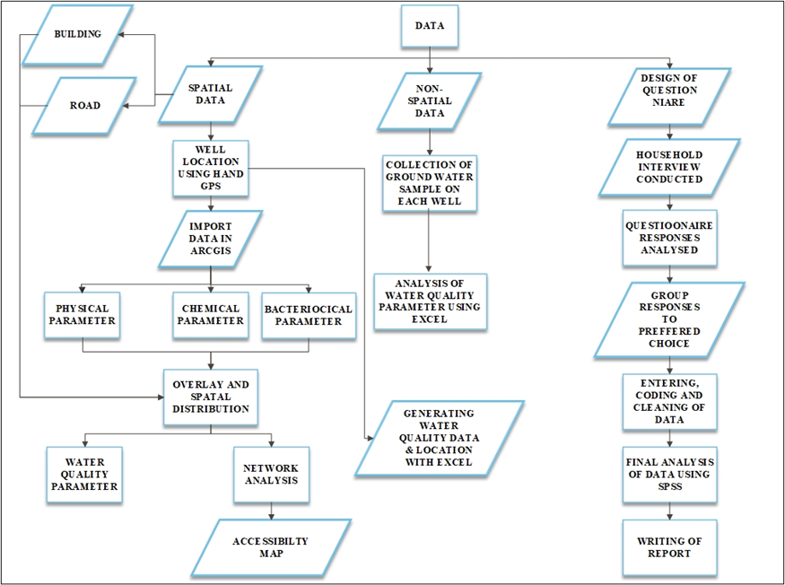

**Fig.3.2. Flow chart for executing various specific objectives**

**RESULTS AND DISCUSSION**

The water point sources are numbered and named as shown in fig. 3.1 and appendix. The data from each source are compared to WHO standards in the appendix and analysed using Excel in 4.1. (a, b). The spatial distribution map is in Fig. 4.2.(a, b). The pH test results for all the sources range from 6.3 to 7.5, which falls within the WHO standard of 6.5 to 8.5. This means that the groundwater is not acidic and suitable for use. However, high pH can cause skin dryness, itchiness, and irritation, as pH measures the relative amount of free hydrogen and hydroxyl ions in the water. The turbidity test results for all the sources are below the WHO threshold of 5, except for source 7 and 9, which have 6.12 and 34.9, respectively. These two sources are not fit for use unless the turbidity level is reduced, as high turbidity can affect the aesthetic quality, recreation, tourism, and treatment cost of the groundwater. The alkalinity test results for all the sources show high concentration of alkaline, which may have some side effects, such as altered blood pH, even though it can also boost the immune system and improve hydration (Smith). Drinking large amounts of alkaline water can slightly change the body’s natural pH balance, as alkaline water has a higher pH than tap water. The iron test results for all the sources show some iron concentration, except for source 7, which has a high concentration of 2.51. Iron is not harmful to health, but it is an aesthetic contaminant, which means consumers can easily detect it and perceive the water quality as low, as shown in figure 4.4 and the appendix.

The chloride and sodium test results for all the sources are below the WHO limits of 250mg/l and 200mg/l, respectively, except for source 9, which has 246mg/l of chloride. This does not have health implications, but it can produce a salty taste and increase the corrosivity of water, which can affect plants, household plumbing, and appliances. The total suspended solid test results for all the sources are below the WHO limit of 10mg/l, except for source 6, which has 15mg/l. This can have health implications, as bacteria, algae, and pollutants can cause gastrointestinal issues or serious effects, as shown in Figure 4.1 and the appendix. The total dissolved solid test results for all the sources are below the WHO limit of 600mg/l, except for source 9, which has 1340mg/l. This does not have health implications, but it can affect the taste, odor, and appearance of the water.

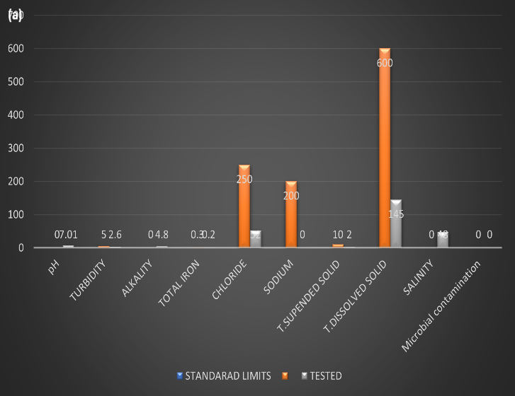

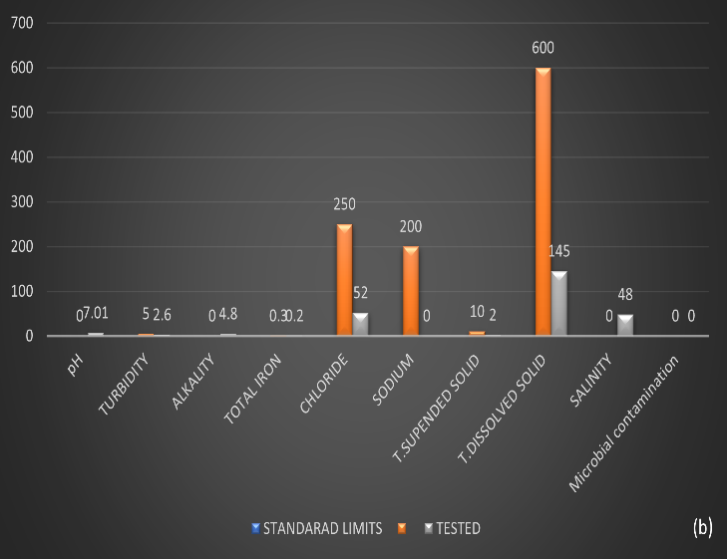

**Fig.4.1 Water Quality Analysis (4.5a) Various Groundwater Quality Parameter with Respect WHO Standard Analysis on groundwater- groundwater location 1; and (4.5b) Groundwater Quality Parameter with Respect WHO Standard Analysis-water location 2 using Excel.**

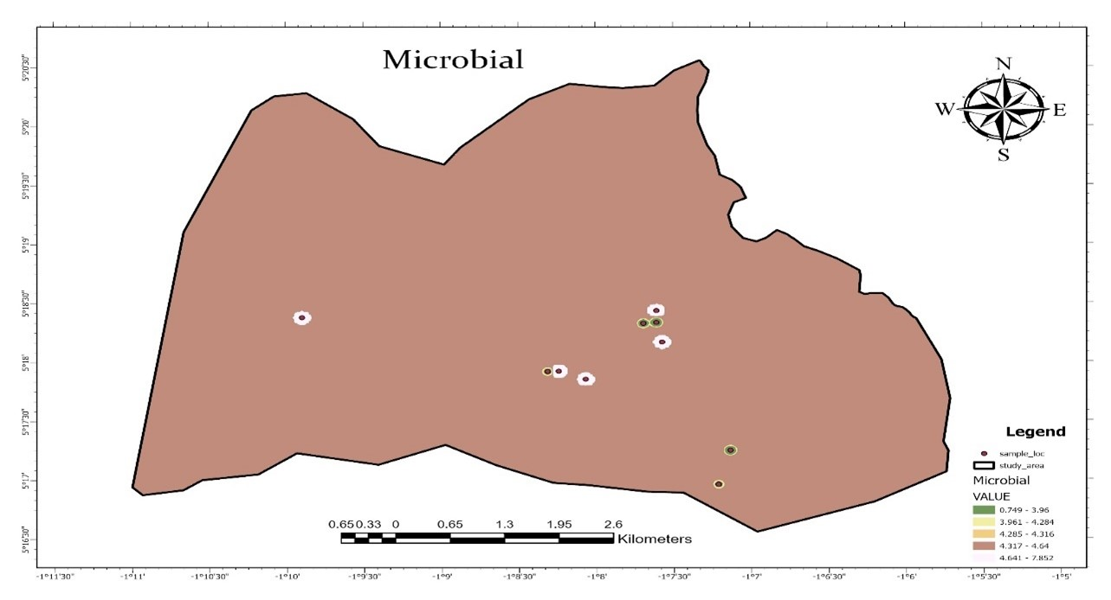

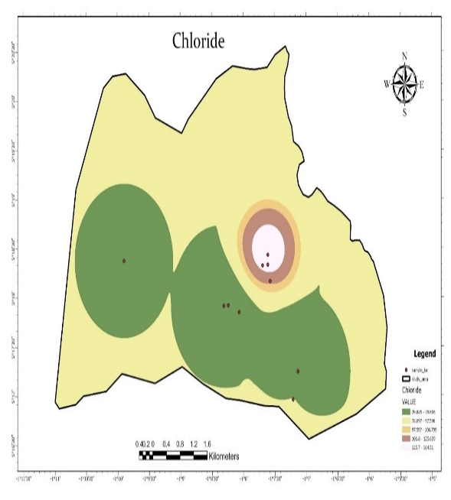

**Fig.4.2: Spatial distribution of microbial (4.6a) and chloride (4.6b) in Groundwater parameter- groundwater location 1 and 2 using GIS, GPS application software**

According to spatial distribution network analysis for study area as it is indicated fig.4.3a and b, it indicates that walking distance from the point source of fetching water to the point of delivery to be used by the various households has been a barrier for accessing groundwater within this communities, because according to the world bank Report, 1997. In defining water access, it indicates that when individuals have access to, a safe water origin, of good quality, proximity allocation should be within 200m from point of the water source to their residence. Furthermore, considerable dalliance of time spent, difficulty in usage of boreholes to access groundwater problematic. But with reference to the accessibility map, residence within Aboase, Obohen and Bentingua community walk for 536m, 495m, 362m respectively to access water which is more than the expected threshold by the World Bank report as indicated in figure 4.3.

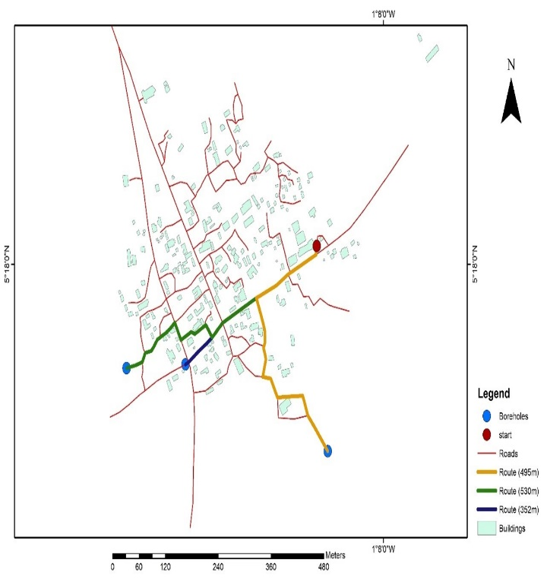

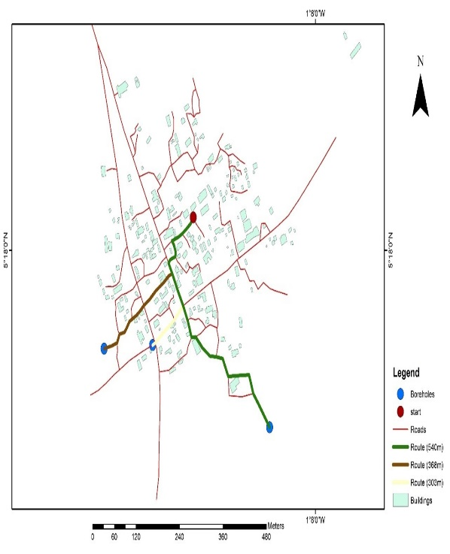

**Fig.4.3: Accessibility Map for water source 1 (4.7a) and water source 2(4.7b) with respect to world bank reference -200m with the use of GIS and GPS application software.**

In the interviews, 40.3% were male, and 59.7% were female (Figure 4.4a). Majority of the administered questionnaires were directed towards female households, given their vulnerability to water-related issues, while many males were engaged in farming activities (Figure 4.4a). Respondents aged 35-50 years (38.7%) were predominantly farmers and traders, and those above 65-70 years (26.6%) were mostly dependent on family support (Figure 4.4b). Regarding education, 57.2% reached primary school, 10.3% went up to Senior High school, 7.8% attended college, and 24.7% never attended school (Figure 4.4c), highlighting challenges in education. The majority were crop farmers (66.7%), livestock keepers (20.2%), and 2.1% were unemployed (Figure 4.4b). Respondents generally agreed that improved water was aesthetically pleasing (Figure 4.4d) and did not corrode their reservoirs (Figure 4.4f). They disagreed that improved water produced turbid water (Figure 4.4h) or had a high concentration of salt (Figure 4.4e). However, accessing water from boreholes was perceived as time-consuming (Figure 4.4i) and affected working hours (Figure 4.4j). Distance as a barrier to accessing water was agreed upon by 59.3% of respondents (Figure 4.4l). Sensitization of agriculture input close to the water source raised contamination concerns, while the health benefits of consuming improved water were acknowledged by 53.9% (Figure 4.4k). Overall, respondents demonstrated awareness of water-related issues and the importance of improved water sources for their communities.

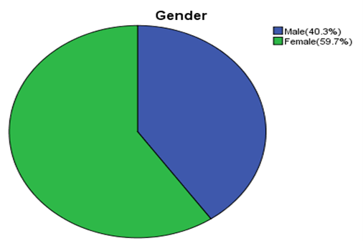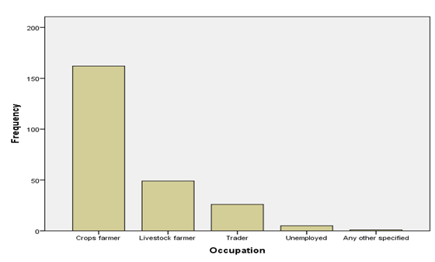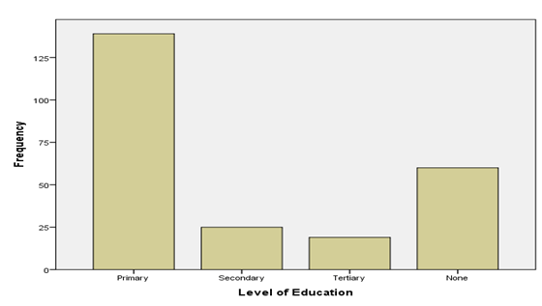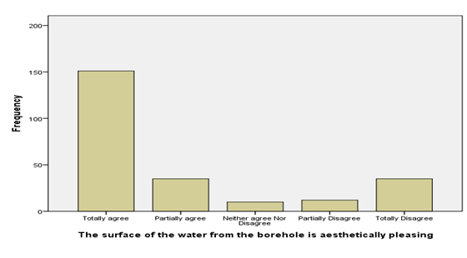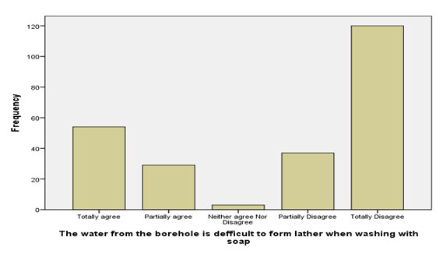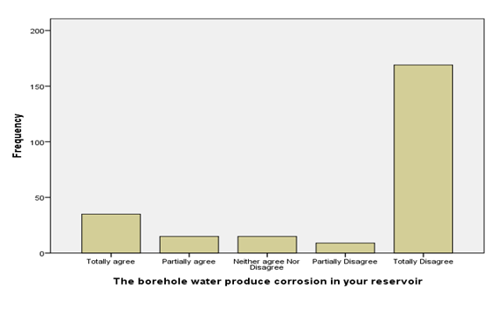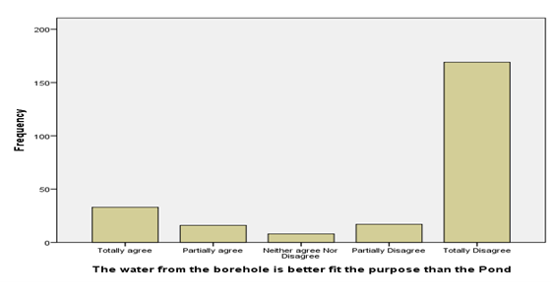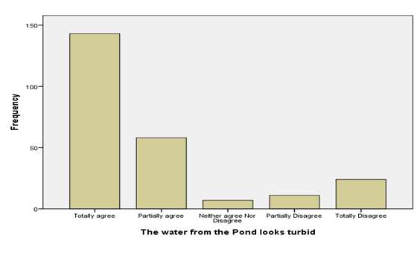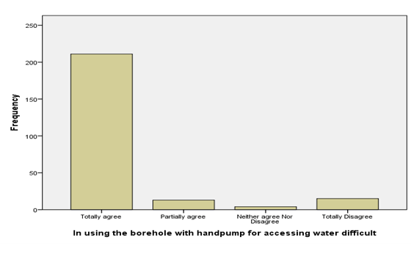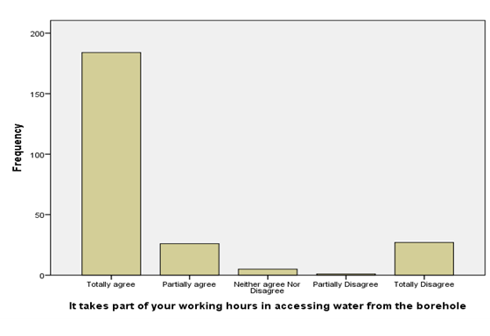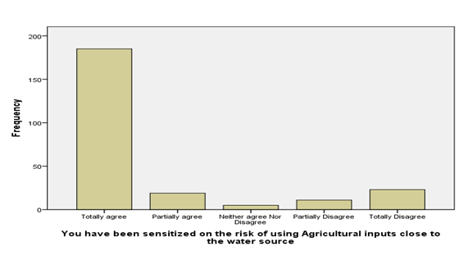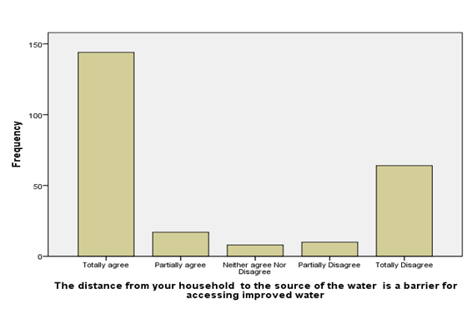

**(b)**

**(a)**

(**g**)

(**d**)

(**c**)

**(h)**

(**e**)

(**j**)

(**i**)

(**f**)

**(k)**

**(l)**

**Fig.4.4: Factors that motivate patronage of the ground water ;percentage of gender(4.8a), kinds occupation engage(4.4b), education level of on the people(4.4c), aesthetically pleasing of borehole water (4.4d), borehole water difficult to form lather when wash with soap(4.4e), borehole water produce corrosion their reservoir when stored(4.4f), borehole water better fit the purpose to that of the pond(4.4g), pond water looks turbid(4.4h),handpump difficul in accessing groundwater(4.4i),water accessibility affecting their working hours(4.4j), sensitized on the risk of applying Agriculture input close to the source of water(4.4k), and distance been a barrier for accessing improved water(4.4l) using SPSS software.**

# DISCUSSION

In examining the groundwater quality status and location within the study area, understanding the catchment's rock formation is essential for revealing its hydrological dynamics. The presence of physicochemical and microbial properties in the rock formation contributes to elevated concentrations within the groundwater, impacting its overall quality. However, challenges arise from the dispersed nature of groundwater sources, compounded by human activities and policy gaps in demanding water quality results before project handover. This reluctance to accept improved water due to concerns about physico-chemical concentrations results in increased water-related diseases and poverty. Moving to proximity and spatial distribution analysis, climate factors influence the complex relationship between water and soil, determining runoff characteristics classified into soil groups A to D. Challenges in digitizing locations on Google Earth hinder spatial analysis, revealing that many people walk considerable distances to access improved water. This highlights the need for catchment area protection policies to prevent negative impacts on well-being, poverty, and food scarcity. Examining factors motivating groundwater patronage reveals anthropogenic activities impacting land use and cover changes due to population growth and economic demands. Over-extraction for economic gain contributes to global climate change, but successful interventions, like the Densu Basin Board, have positive effects on preventing soil erosion and improving water quality. Poor road networks and time constraints for farming communities affect questionnaire administration, reflecting challenges in conducting research in such environments.

# CONCLUSION AND RECOMMENDATION

In Conclusion, the study utilized eleven groundwater sources, employing traditional laboratory tests, GIS, GPS, and Google Earth to assess water quality parameters and spatial distribution. The results, presented in charts and maps, revealed that most sources met WHO standards, except for a few with elevated concentrations of certain parameters due to anthropogenic activities. Accessibility challenges were highlighted through GIS mapping, emphasizing the need for improved infrastructure. The questionnaire-based survey, analyzed with SPSS, identified factors influencing improved groundwater patronage, indicating a generally low motivation level. The study recommends regular water quality analyses by MMDAs, emphasizing the use of traditional laboratory methods for accuracy. Additionally, policymakers should focus on infrastructure development to enhance accessibility and encourage improved groundwater use in the communities.

# ACKNOWLEDGEMENT

I want to thank the many people who help in the data collection and processing of the study. I will also want to thank the reviewers of the work.

# REFERENCES

Anim-Gyampo, M., Anornu, G., and Abudu Kasei, R. (2012). Prediction of Potential Groundwater Over-abstraction: ASafe-yield Approach-A Case Study of Kasena-Nankana District of UE Region of Ghana. *Research Journal of Applied Sciences, Engineering and Technology*, *4*(19), 3775–3782.

Creswell, J. W. (1994). *Research design: Qualitative & quantitative approaches.* Sage Publications, Inc.

Cromwell, E. A., Schmidt, C. A., Kwong, K. ., Pigott, D. M., Mupfasoni, D., Biswas, G., and Al., E. (2020). The global distribution of lymphatic filariasis, 2000–18: a geospatial analysis. *Lancet Glob Health.*, *8*(9), e1186–94.

De Boer, W. F., and Baquete, D. S. (1998). Natural resource use, crop damage and attitudes of rural people in the vicinity of the Maputo Elephant Reserve, Mozambique. *Environmental Conservation*, *25*(3), 208–218. https://doi.org/10.1017/S0376892998000265

Ganyaglo, S. Y., Banoeng-Yakubo, B., Osae, S., Dampare, S. B., and Fianko, J. R. (2011). Water quality assessment of groundwater in some rock types in parts of the eastern region of Ghana. *Environmental Earth Sciences*, *62*(5), 1055–1069.

Krejcie, R. V., and Morgan, D. W. (1970). *Determining Sample Size for Research Activities. Educational and Psychological Measurement. Small-Sample Techniques (1960).* (Vol. 38). The NEA Research Bulletin.

Madhav, S., Ahamad, A., Kumar, A., Kushawaha, J., Singh, P., and Mishra, P. . (2018). Geochemical assessment of groundwater quality for its suitability for drinking and irrigation purpose in rural areas of Sant Ravidas Nagar (Bhadohi), Uttar Pradesh. *Geology, Ecology, and Landscapes*, *2*(2), 125–136.

Mukherjee, P., Singh, C. K., and Mukherjee, S. (2012). Delineation of Groundwater Potential Zones in Arid Region of India—A Remote Sensing and GIS Approach. *Water Resources Management*, *26*(9), 2643–2672. https://doi.org/10.1007/s11269-012-0038-9

Ntow, W. J. (2001). Organochlorine Pesticides in Water, Sediment, Crops, and Human Fluids in a Farming Community in Ghana. *Archives of Environmental Contamination and Toxicology*, *40*(4), 557–563. https://doi.org/10.1007/s002440010210

Sahbeni, G., Pleynet, J. B., and Jarocki, K. (2023). A spatiotemporal analysis of precipitation anomalies using rainfall Gini index between 1980 and 2022. *Atmospheric Science Letters,* e1161.

Schaeffer, A. J., and Lebedev, S. (2013). Global shear speed structure of the upper mantle and transition zone. *Geophysical Journal International*, *194*(1), 417–449. https://doi.org/10.1093/gji/ggt095

World Health Organization (WHO). (2004). *Guidelines for Drinking Water Quality Recommendations* (Vol. 1).